***Seal User Manual (admin)***



**…………………………………………………………………………**

Table of Contents

1.0. Log In 3

1.1. View Users 4

2. 0.View Inventory 5

2.2. Inventory Status 6

3.0. Add Information 7

3.1. Add New User 7

3.2. Add New User 8

4.0. View Profile 8

4.1. Edit Information 9

5.0. View Purchase History 9

5.1. View Report 10

6.0. Sign Out 11

# 1.0. Log In

To avail the services of ***Seal***, the admin should log in to the system. Click on Manage Your Seal Account. Two options will be shown: Customer and Admin. Click on the Admin option:

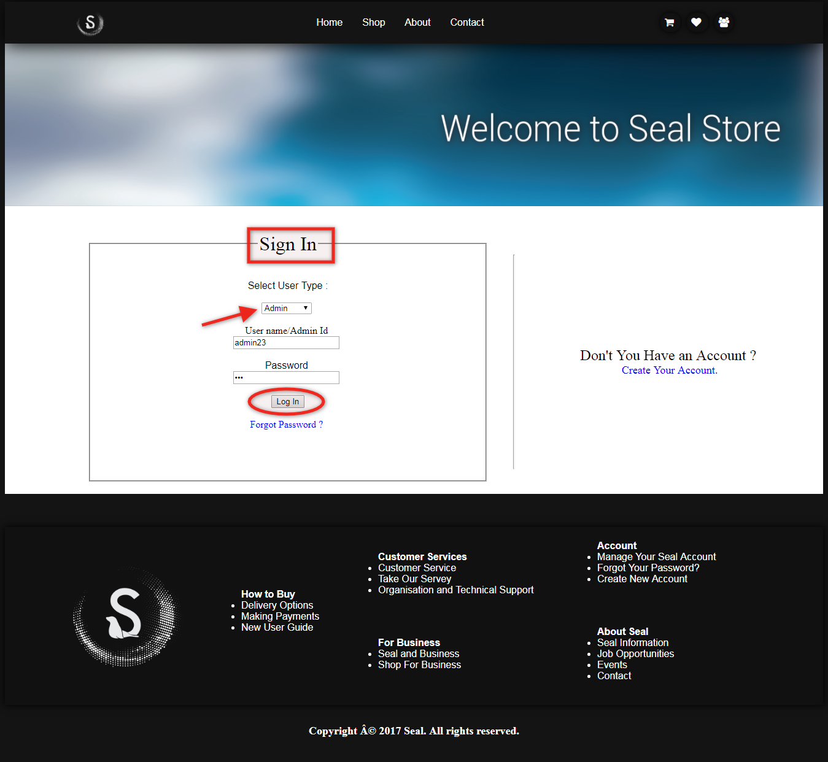

## 1.1. View Users

Admin will login to the system to view user and their details .Click on users to view users and admin can update users information if required.

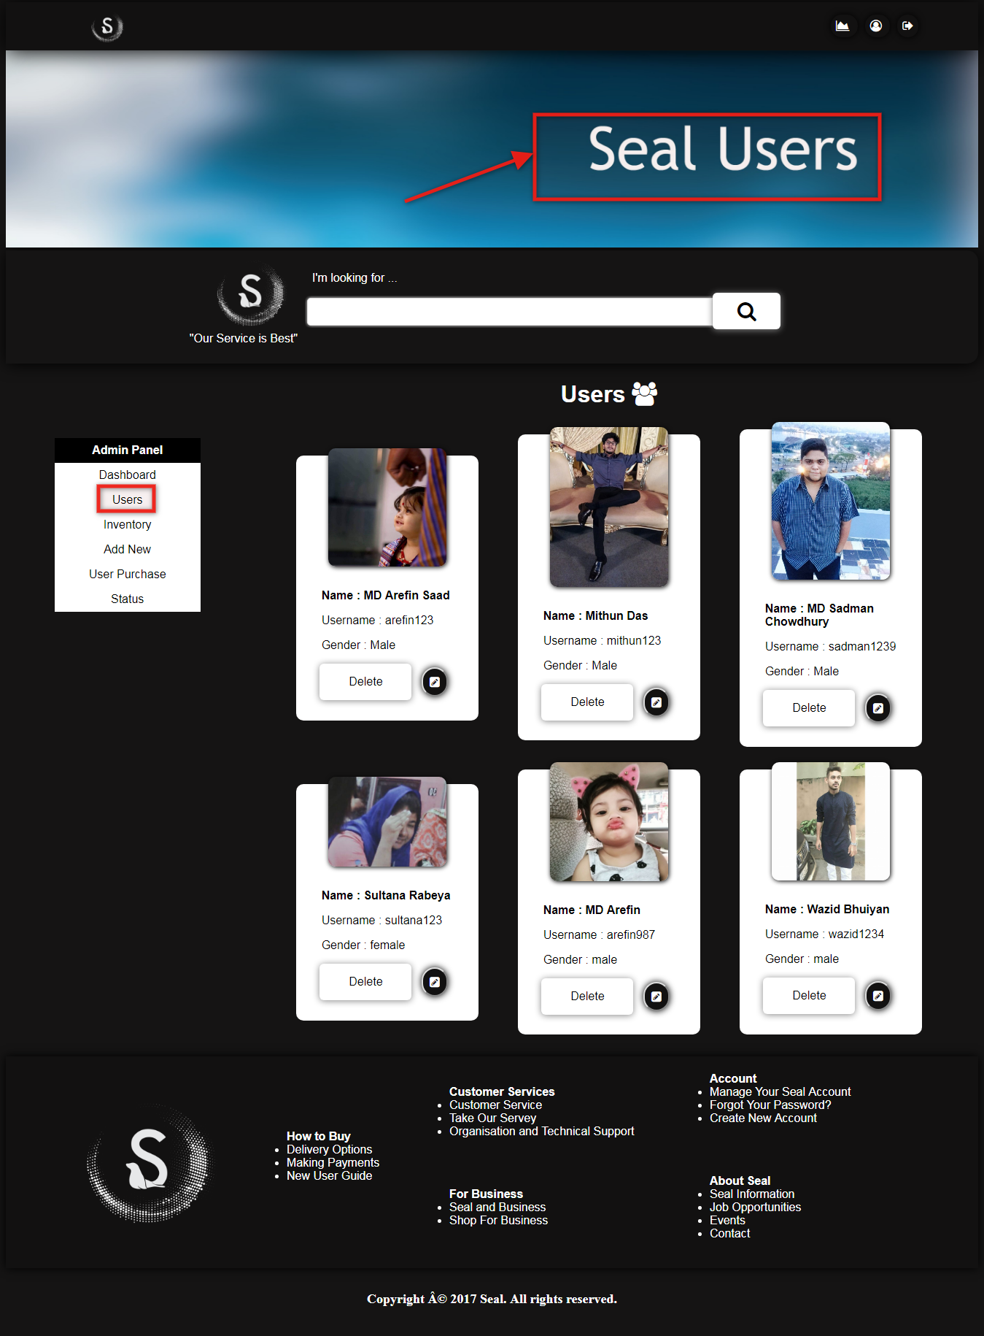

# 2. 0.View Inventory

Click on Inventory to view products and their price.

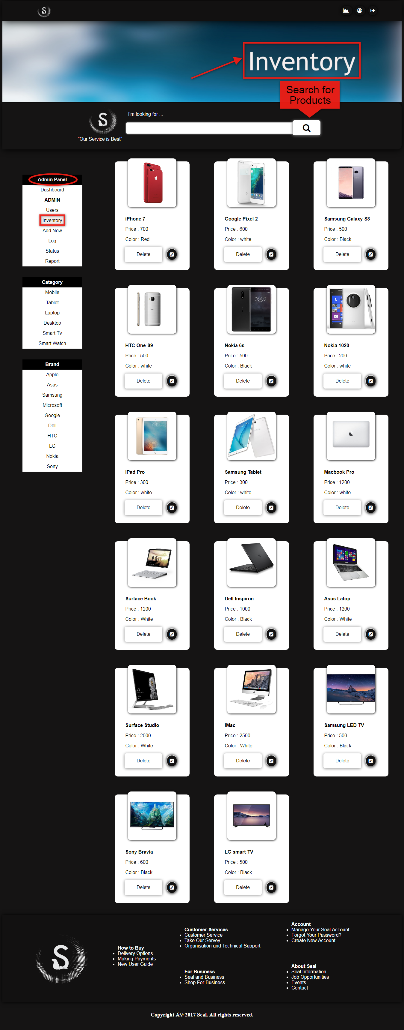

## 2.2. Inventory Status

Click on status to view inventory status of user in details.

# 3.0. Add Information

Click on Add New to add new user and new product.

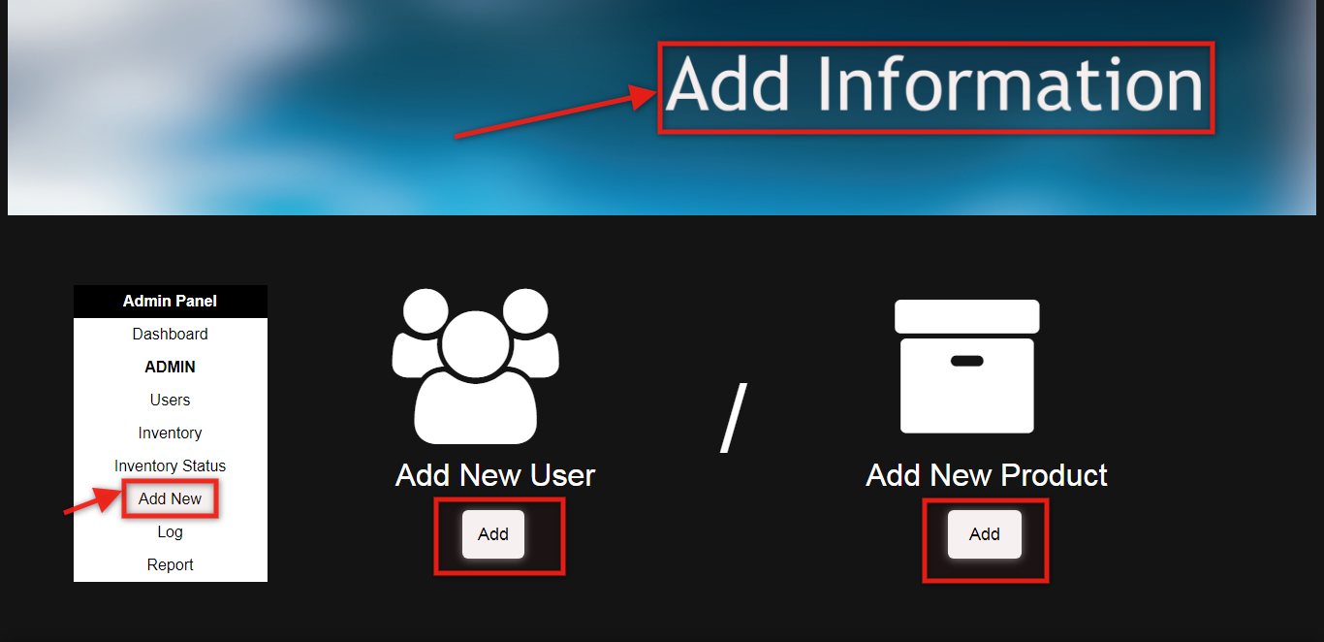

## 3.1. Add New User

Click on Add below Add New User and fill up the form to create new user.

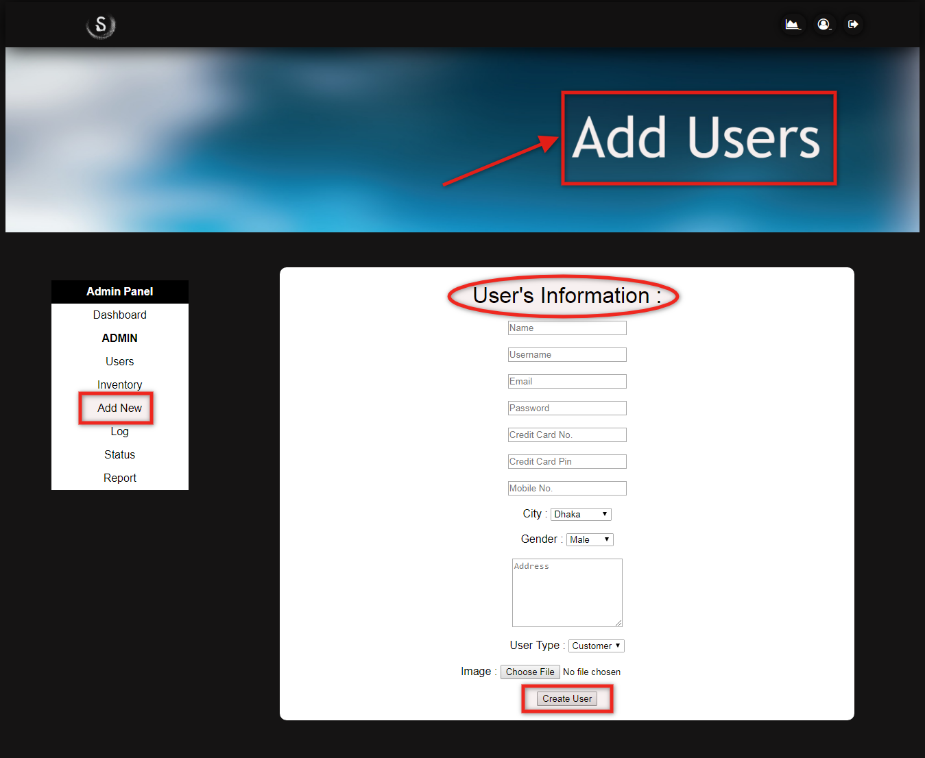

## 3.2. Add New User

Click on Add below Add New Product and fill up the form to insert new product.

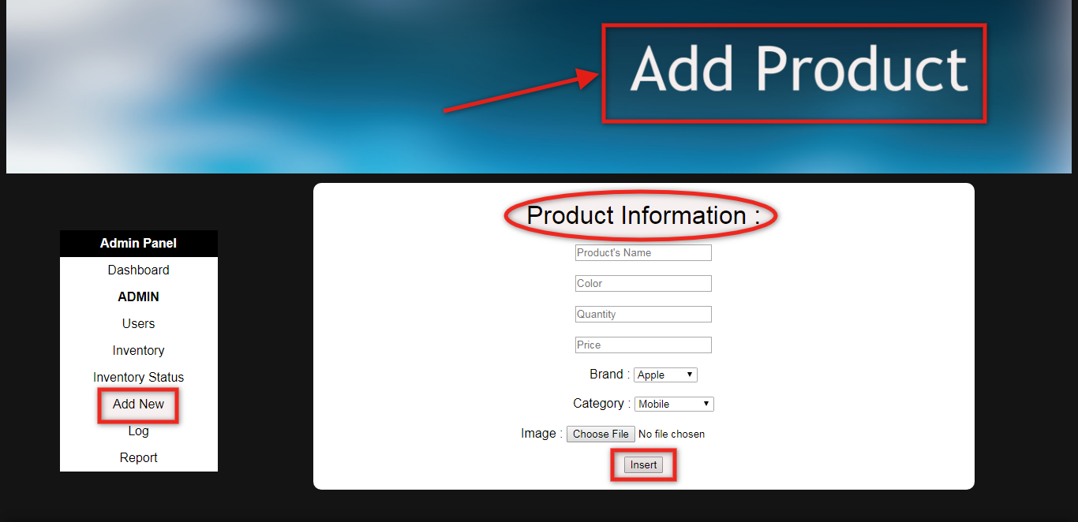

# 4.0. View Profile

Click on profile icon at the top of the page to view profile.

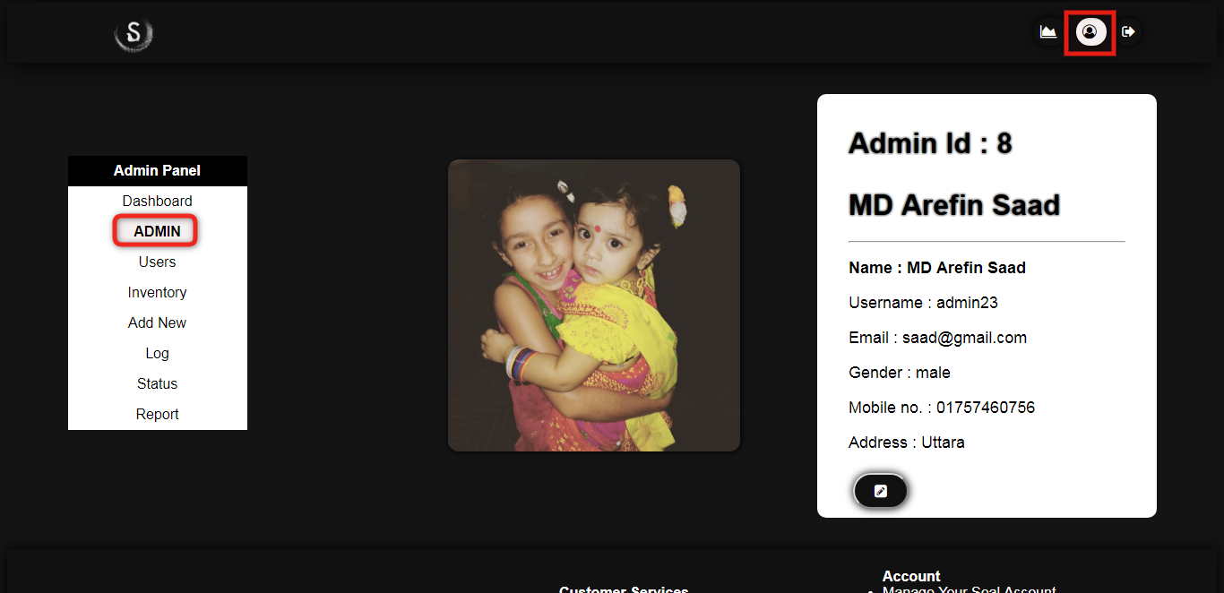

## 4.1. Edit Information

Admins can update their general information by filling up the following form.

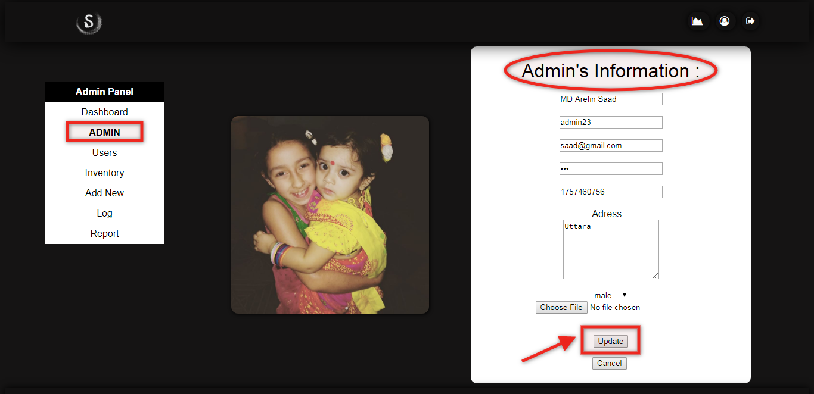

# 5.0. View Purchase History

Click on Log to view purchase history of users.

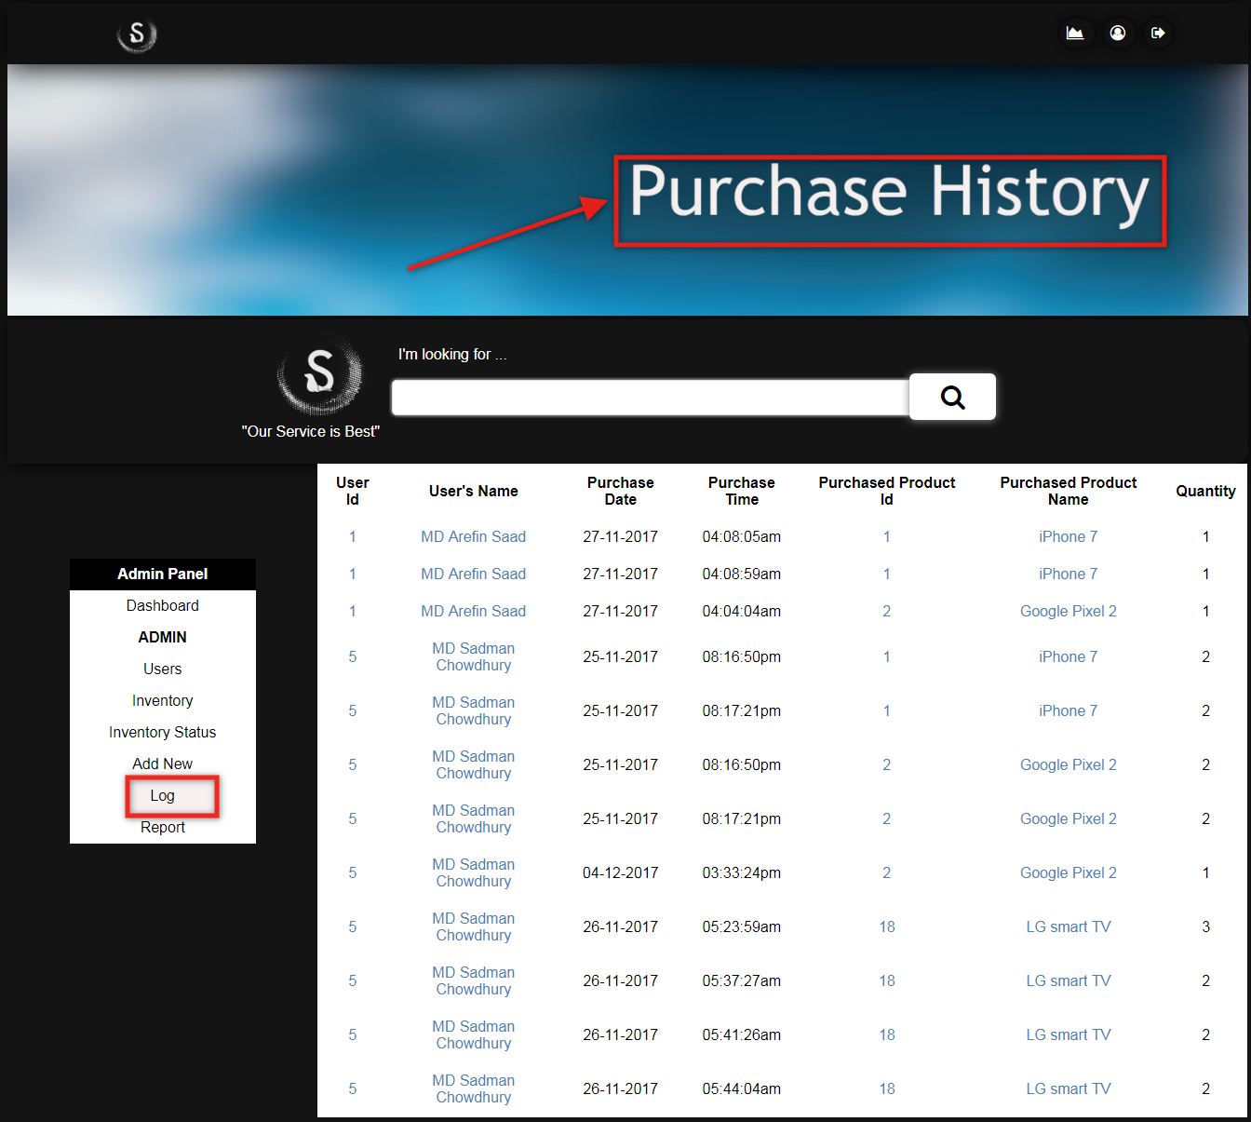

## 5.1. View Report

Click on Report to view percentage of male and female employee.

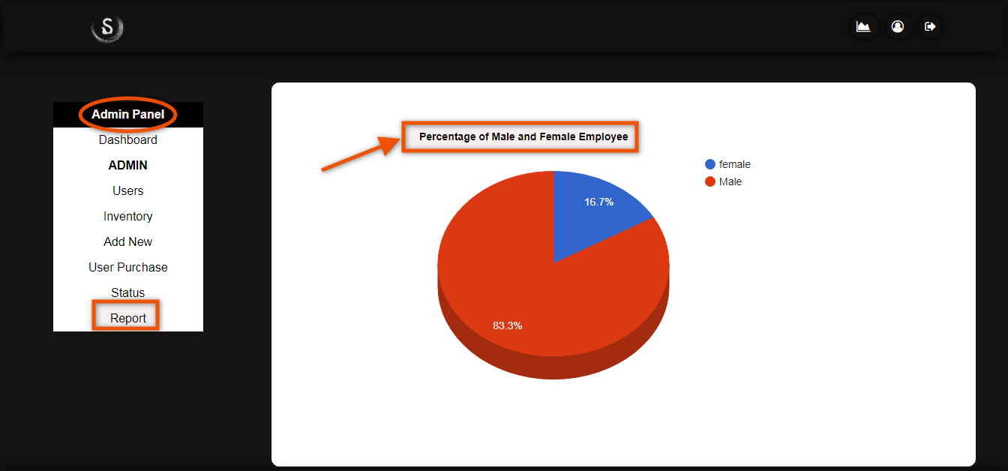

# 6.0. Sign Out

After completing the application process log out of the account. Click on arrow icon beside profile icon to sign out of the system.

